Sectoral Analysis of Indian Stock Market Indices
Student Author Name
Roll Number Here

A project report submitted for the MA (IInd Semester)
Submitted to
Teachers Name Here



Department of Economics
Aligarh Muslim University
Date of Submission: 2025-05-16

Table of Contents
Abstract 4
1. Introduction 1
2. Data and Methodology 1
2.1 Data 1
2.2 Methodology 1
3. Results and discussion 1
3.1 Trend Analysis 1
3.2 Normality of Returns 3
3.3 Difference in Mean Returns 4
3.4 Correlation Between Sectors 4
3.5 Predicting Banking Returns 4
3.6 Volatility Comparison 4
4. Conclusion 5
5. References 5
6. Appendix: R Code 6

List of Figures
Figure 1: Trend of Bank Index 2
Figure 2: Trend of IT Index 2
Figure 3:Trend of FMCG Index 3
Figure 4: Normality of Returns 3
Figure 5:Correlation among sectoral returns 4

List of Tables
Table 1:ANOVA Results for Sectoral Returns 4
Table 2:Regression Model Predicting Bank Returns 4
Table 3:Sector-wise Volatility 4

Abstract
Abstract of the project goes here.

1. Introduction
Introduction of the study goes here. For example, see the below paragraph. Sectoral indices reflect the performance of key industries within the stock market. Understanding their behavior is crucial for investors, policymakers, and analysts. This report addresses the following research questions:
- What are the trends in sector indices from 2020–2025?
- Are daily returns normally distributed?
- Do average returns differ significantly across sectors?
- Are sector returns correlated?
- Can banking returns be predicted using IT and FMCG?
- Which sector is the most volatile?
- Do returns follow a random walk?
- Is there a causal relationship among sectors?

2. Data and Methodology

2.1 Data
Write here about the data here.

2.2 Methodology
Write here, about the methods used for the analysis.

3. Results and discussion
Write here about the results which have been obtained after employing above stated methodologies and discuss about the results.

3.1 Trend Analysis
$Bank
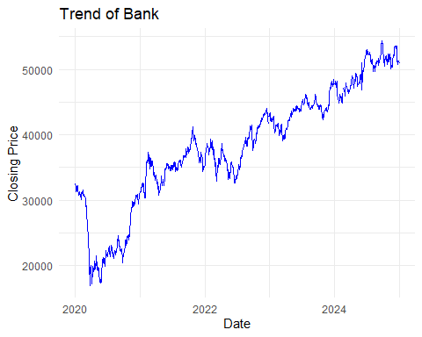
Figure 1: Trend of Bank Index
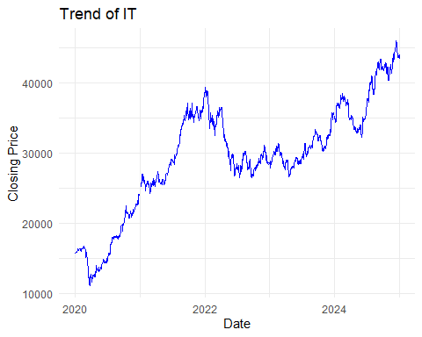
Figure 2: Trend of IT Index
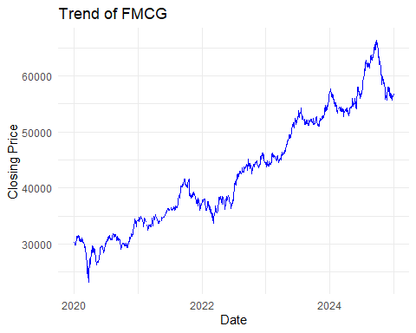
Figure 3:Trend of FMCG Index

3.2 Normality of Returns
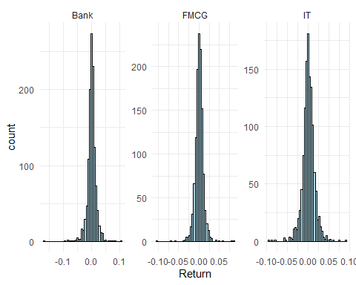
Figure 4: Normality of Returns

3.3 Difference in Mean Returns
Table 1:ANOVA Results for Sectoral Returns
term | df | sumsq | meansq | statistic | p.value
Sector | 2 | 0.0001347 | 0.0000674 | 0.3336359 | 0.7163362
Residuals | 3684 | 0.7438068 | 0.0002019 | NA | NA

3.4 Correlation Between Sectors
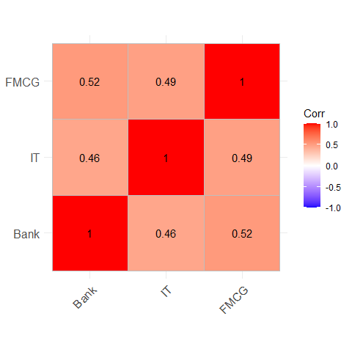
Figure 5:Correlation among sectoral returns

3.5 Predicting Banking Returns
Table 2:Regression Model Predicting Bank Returns
term | estimate | std.error | statistic | p.value
(Intercept) | -0.0001161 | 0.0003834 | -0.3028521 | 0.7620542
IT | 0.2968386 | 0.0292104 | 10.1620744 | 0.0000000
FMCG | 0.5770344 | 0.0405883 | 14.2167794 | 0.0000000

3.6 Volatility Comparison
Table 3:Sector-wise Volatility
Sector | Volatility
Bank | 0.0162709
IT | 0.0149595
FMCG | 0.0107960
The analysis indicates that sectoral indices show distinct dynamics. Banking sector returns exhibit higher volatility, while FMCG remains relatively stable. ANOVA and regression models suggest statistically significant differences and predictive relationships across sectors. ADF results reject the random walk hypothesis, suggesting the market is not fully efficient.

4. Conclusion
This report highlights structural differences across sectors, predictive linkages, and implications for market efficiency. These insights support diversification strategies and inform policy planning in financial regulation.

5. References
- Fama, E. F. (1970). Efficient Capital Markets: A Review of Theory and Empirical Work.
- Lo, A. W., & MacKinlay, A. C. (1988). Stock Market Prices Do Not Follow Random Walks.
- Mishra, A. K., & Sethi, D. (2021). Sectoral Returns and Macroeconomic Variables: Evidence from Indian Stock Market.

Appendix: R Code
Paste all R code here.

